**Introduction to Amazon Redshift**

Time spent : 60min

**What I learned**

1. How to lunch the Redshift cluster

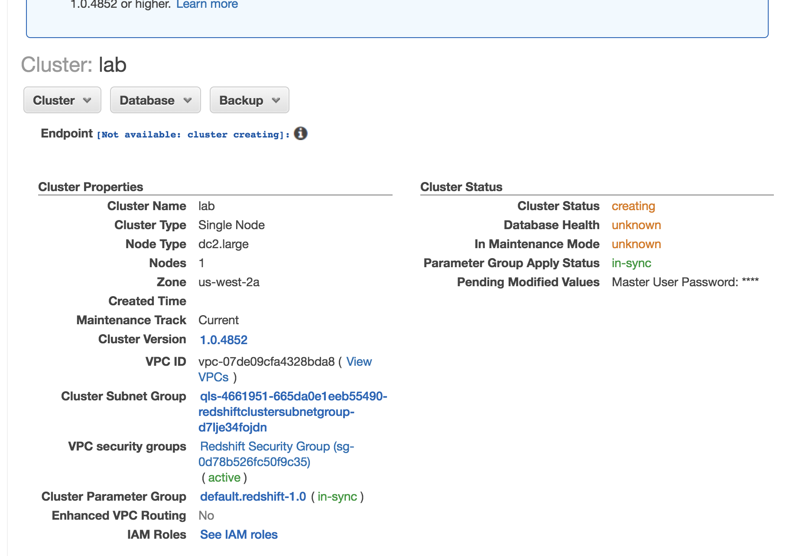

1. How to connect it to the PgSQL

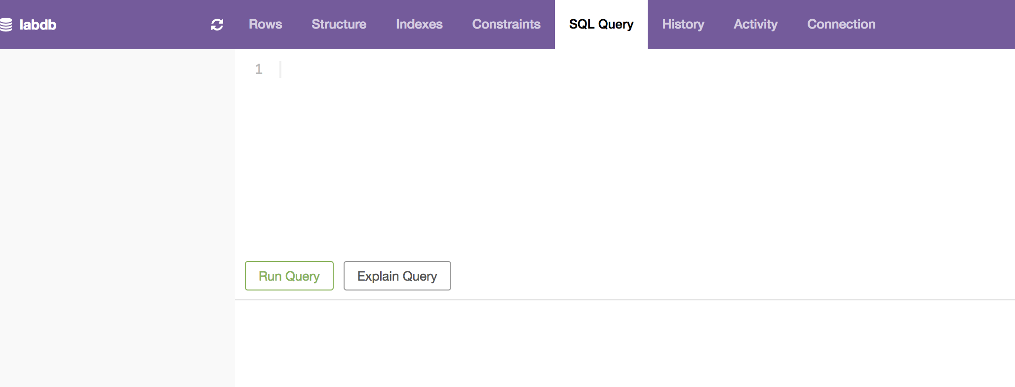

1. Load data from amazon S3

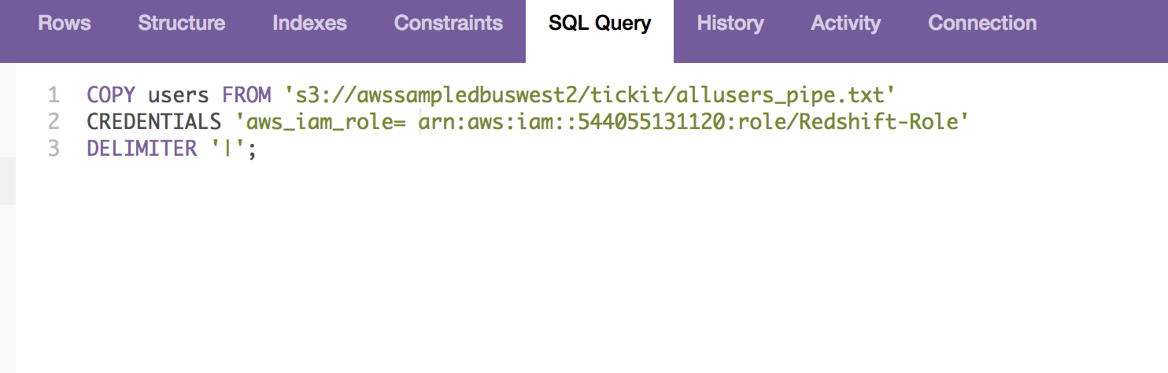

1. Query the data

Summary:

In this lab, I learned how to use Amazon redshift to build the host server and implement in this data warehouse .